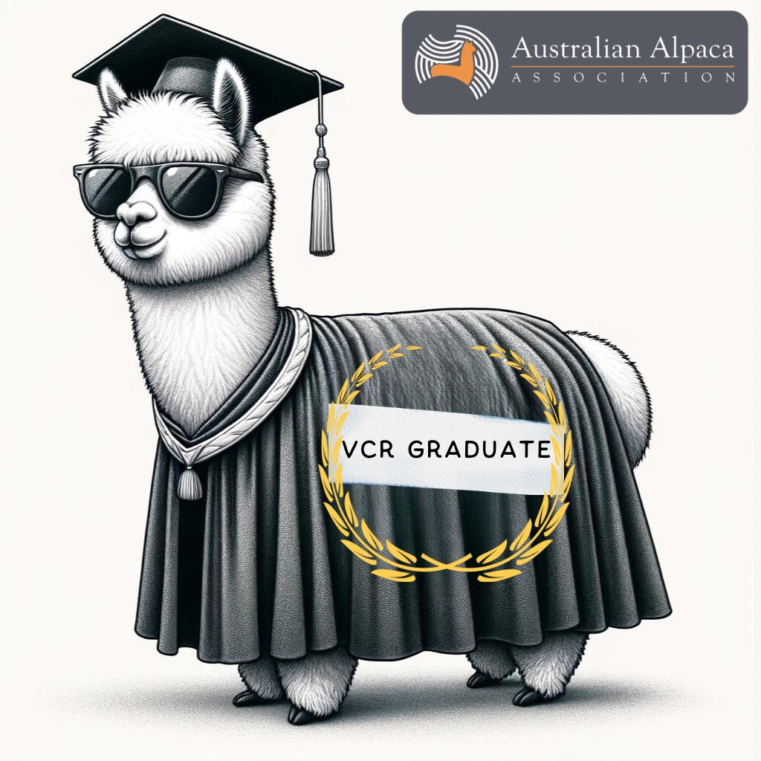

VCR - Alpaca Handling Workshop.
Saturday 9th May 10am – 4pm.
MillDuck Alpaca Stud. 143 Ford Road, Harcourt North (near Bendigo)

Do you want your alpacas to be calm and responsive, making it easy to halter train, trim toenails, vaccinate, load in your trailer – then this workshop is for you.
Prue Walduck from MillDuck Alpaca Stud, who has 33 years’ experience breeding, handling and showing alpacas, will share how she interacts with her alpacas making all husbandry activities enjoyable and safe for both you as the handler and the alpacas.

Cost : AAA Members - $20 per person or $35 for two Members from the same family.
Non-AAA Members - $45 per person or $85 for two non-members from the same family.
Attendance is limited with priority given to VCR members and non-members in the VCR Region.

Registration: Closes Friday 1 May 2026.
- AAA Members - via e-alpaca.
- Non-members – email Prue (alpacas@millduck.com.au) for instructions on how to register as a guest on e-alpaca.
BYO: Chair & Lunch

Don’t delay – register today

